HARDWARE DOCUMENT

Project: ECSE 211 Search & Retrieval Robot
Task: Overall hardware and structural design

Document Version Number: 2.9
Date: April 8, 2020
Author: Yazdan Zinati
Edit History:
Date | Version | Author(s) | Changes
Feb 25 | 1.0 | Yazdan Zinati | First draft
Feb 25 | 1.1 | Yazdan Zinati | Elaborated sections 1.0 - 9.0
Feb 25 | 1.2.1 | Andy Li  William Bouchard | Improved formatting and table of contents
Mar 8 | 2.0 | Yazdan Zinati | Created sections 10.0 and 11.0
Mar 9 | 2.1 | Yazdan Zinati | Elaborated sections 9.1, 9.1.2, 9.3
Mar 10 | 2.2 | Yazdan Zinati | Created sections 9.4 - 9.7
Mar 10 | 2.3 | Trevor Tabah | Elaborated section 9.2
Mar 10 | 2.4 | Andy Li | Updated formatting and editing
Mar 10 | 2.5 | Trevor Tabah | Elaborated section 9.2 and formatting
Mar 10 | 2.6 | Yazdan Zinati | Elaborated Section 1.0
Mar 31 | 2.7 | Trevor Tabah | Fixed Description
Mar 31 | 2.8 | Yazdan Zinati | Elaborated section 9.7.1
Apr 7 | 2.8.1 | Yazdan Zinati | Added pictures to section 9.4
Apr 8 | 2.9 | Yazdan Zinati | Created section 10.0

1.0 – TABLE OF CONTENTS

2.0 – HARDWARE DESIGN PROCESS 4
3.0 – PURPOSE 4
4.0 – RESOURCES 4
5.0 – DESIGN CONSTRAINTS 4
6.0 – RESEARCH AND DEVELOPMENT 4
7.0 – DESIRED FEATURES AND REQUIRED COMPONENTS 5
8.0 – PRELIMINARY DESIGN 6
8.1 – COMPONENT COUNT AND PLACEMENT 6
8.2 – PRELIMINARY DESIGNS 7
8.2.1 – PRELIMINARY DESIGN 1 7
8.2.2 – PRELIMINARY DESIGN 2 9
8.2.3 – PRELIMINARY DESIGN 3 11
9.0 – FIRST DRAFT OF CHOSEN DESIGN 13
9.1 – DESIGN DECISIONS 13
9.2 – DESCRIPTION 13
Components: 13
Features: 14
9.3 – IMAGES 15
9.4 – EVALUATION TABLE 17
9.5 – FUTURE IMPROVEMENTS 18
9.7 – TIMELINE OF DESIGN MODIFICATION 19
9.7.1 – ROBOT V1.1 19
9.7.1.1 – EVALUATION TABLE 19
10.0 – COVID-19 UPDATE 20
10.1 – Instructions on resuming the hardware design 20
11.0 – TESTS 21
12.0 – GLOSSARY OF TERMS 21

2.0 – HARDWARE DESIGN PROCESS
We started the design process of the robot based on three important documents: the System Document, which defines the available hardware, its capabilities and limitations, and key features (e.g., reusability and compatibility); the Requirements Document, which defines the purpose, constraints, and desired features of the robot; and the Constraints Document, which shows the limitations we must consider in the hardware design.
We created the preliminary designs based on the design features, taking into account the constraints and limitations we must work with. We then expect to evaluate and compare the relative advantages of each design to narrow down our ideas to the preferred design of the hardware. However, even this preferred design may be later modified to resolve unexpected problems in the future.

3.0 – PURPOSE
For a detailed discussion of the purpose, refer to Section 2.0 of the Requirements Document.

4.0 – RESOURCES
The resources are those found in the three Mindstorms EV3 kits, the contents of which are listed in Section 3.0 of the System Document.

5.0 – DESIGN CONSTRAINTS
The design constraints are listed in the Constraints Document.

6.0 – RESEARCH AND DEVELOPMENT
Since the beginning of this course, we have completed five labs that address different elements of our final design; thus, the hardware design from the previous labs is relevant to our final project. Since the first four labs were completed in smaller labs than Lab 5, we were able to integrate components from each lab in the hardware design for the final lab (Figure 1). We expect to use elements from this hardware design for the project, as we plan to use a similar array of sensors and motors on the final design.
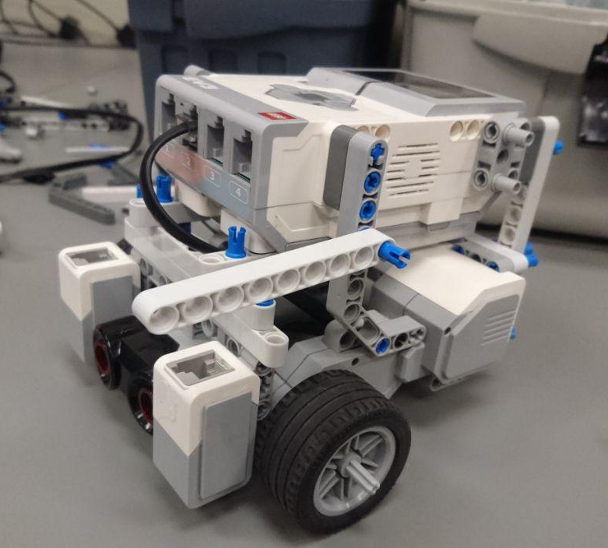
Figure 1: Lab 5 base robot design

7.0 – DESIRED FEATURES AND REQUIRED COMPONENTS
Localization:
- 1 ultrasonic sensor
- 1-2 light sensors (only if light localization is used)

Odometer error correction:
- 2 light sensors

Navigation:
- 2 large motors
- 1 steel ball bearing

Obstacle avoidance:
- 1-2 ultrasonic sensors

Hooking mechanism:
- 1-2 medium motors

8.0 – PRELIMINARY DESIGN

8.1 – COMPONENT COUNT AND PLACEMENT
Ultrasonic sensors
Placement | Advantages | Disadvantages
Bottom, center  (1 sensor) | Detects low obstacles  Localizer code can be reused | Increases width, wheelbase
Top, center  (1 sensor) | Reduces width, wheelbase  Localizer code can be reused | Increases robot height  Only detects tall obstacles  Reduced obstacle detection
Top, forward  (2 sensors) | Reduces width, wheelbase  Improved obstacle detection | Increases robot height  Only detects tall obstacles  Localizer code must be rewritten
Facing outward  (2 sensors) | Improved obstacle detection | Localizer code must be rewritten  Increases robot width

Light sensors
Placement | Advantages | Disadvantages
None | Reduces robot width  No coding necessary | No odometer correction
Back of robot  (1 sensor) | Reduces robot width  Localizer code can be reused | Robot must spin to correct odometer
Sides of robot  (2 sensors) | Quick odometer correction | Increases robot width, power consumption  Localizer code must be rewritten

8.2 – PRELIMINARY DESIGNS

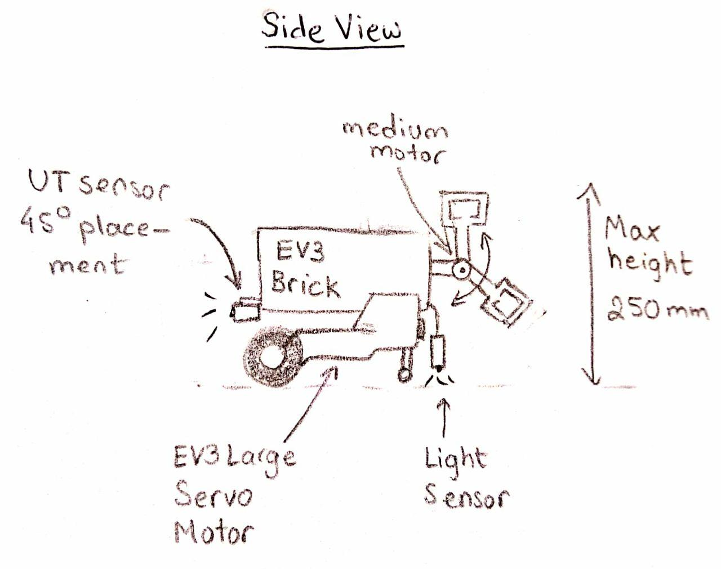
8.2.1 – PRELIMINARY DESIGN 1
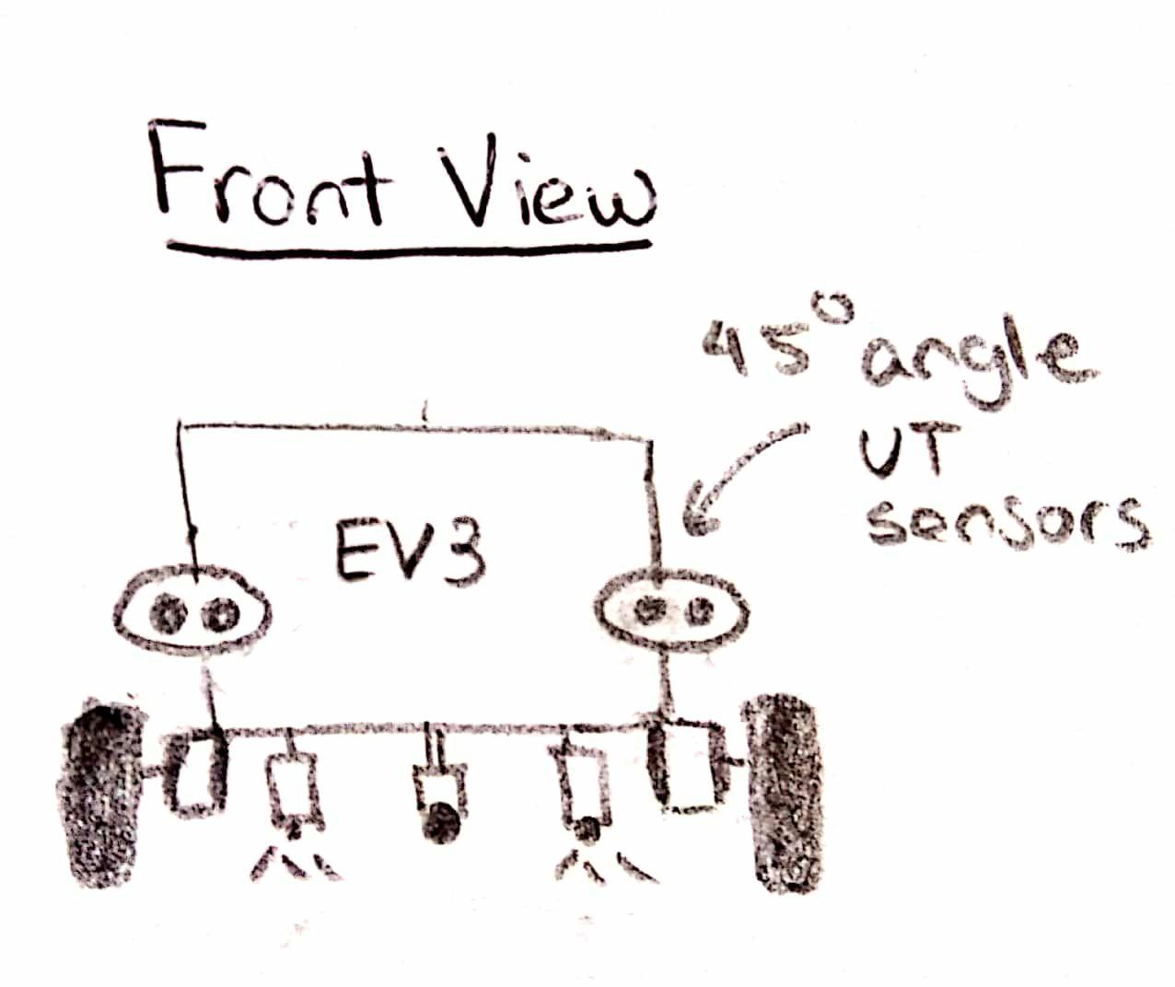
Figure 2: Sketch of the first proposed design
This design (Figure 2) consists of two ultrasonic sensors, each placed at a 45 degree angle in the front of the robot, for object detection and ultrasonic localization. Two light sensors, mounted in the back, can be used for odometer correction and light localization. Placing the light sensors in the back reduces the width of the robot. Other variations of this robot could have bottom mounted motors to further reduce the width.
Components:
- 2 wheels
- 2 large EV3 motors
- 1 medium motor
- 2 ultrasonic sensors
- 2 light/colour sensors

Advantages:
- Relative simplicity
- Two light sensors improve odometer correction
- Reduced robot width

Disadvantages:
- Motor at back of robot adds weight
- Ultrasonic localization requires new code
- Small distance between light sensors reduces accuracy

8.2.2 – PRELIMINARY DESIGN 2
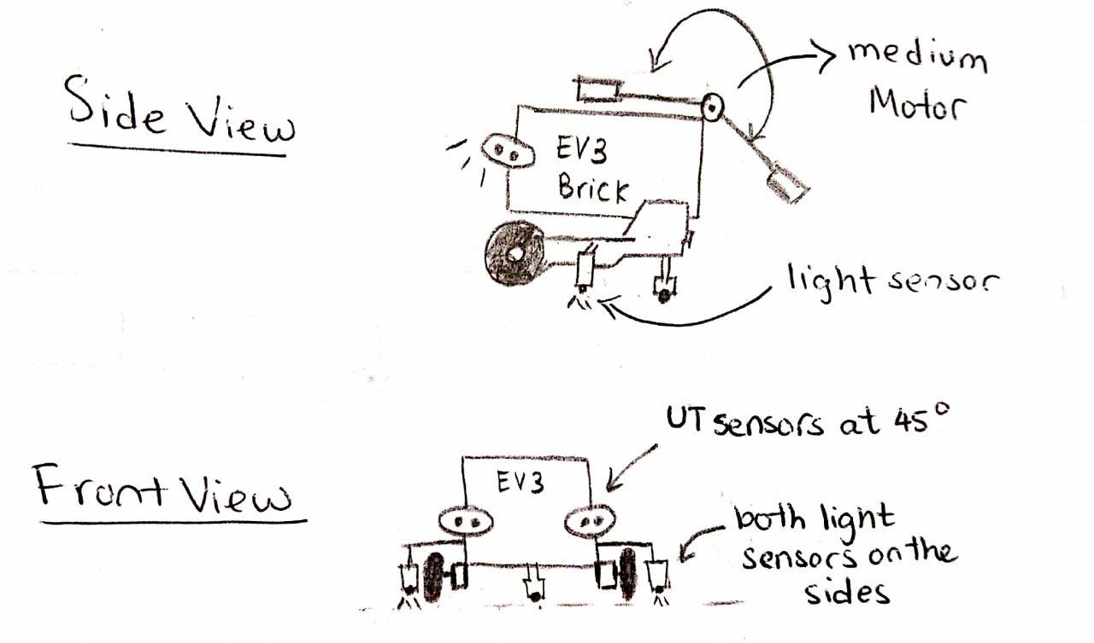
Figure 3: Sketch of the second proposed design
This design (Figure 3) contains two ultrasonic sensors, each placed at a 45-degree angle in the front of the robot; the two sensors are used for both object detection and ultrasonic localization. Two light sensors, which can be used for odometer correction and light localization, are also mounted on the sides. The large distance between the side mounting light sensors makes detecting the odometer error easier. However, the robot is also wider, which could cause issues in the tunnel or when turning.
Components:
- 2 wheels
- 2 large EV3 motors
- 1 medium motor
- 2 ultrasonic sensors
- 2 light/colour sensors

Advantages:
- Two light sensors improve odometer correction, reduce drift
- Distance between sensors increases sensor accuracy
- Improved front-back weight balance

Disadvantages:
- Width of robot reduces maneuverability
- Ultrasonic localization requires new code

8.2.3 – PRELIMINARY DESIGN 3
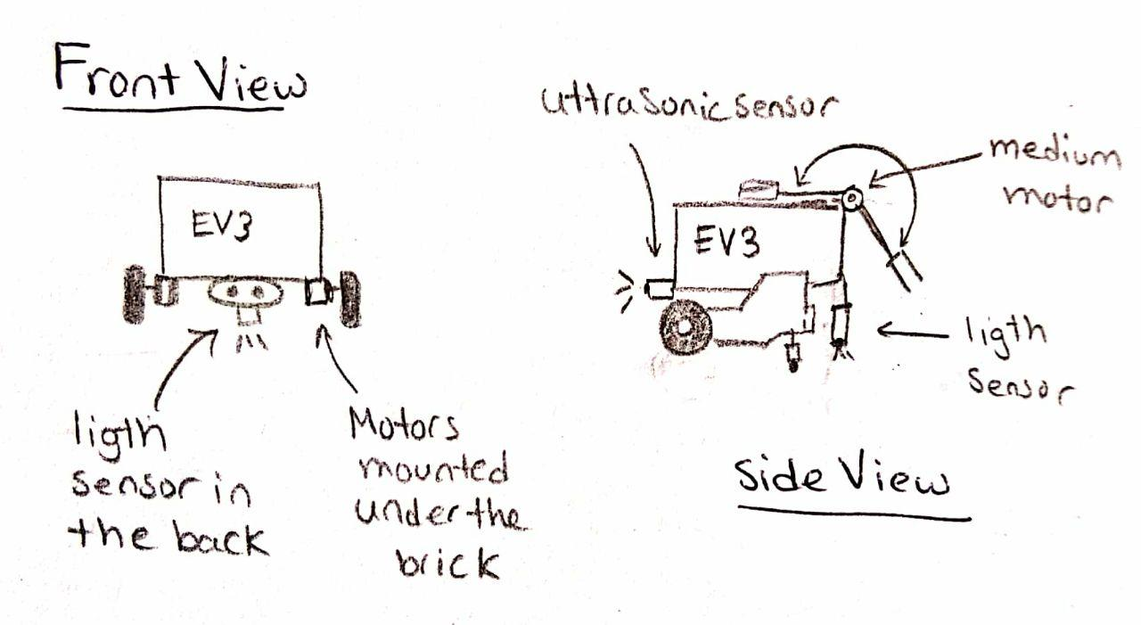
Figure 4: Sketch of the third proposed design
This design resembles the robot we used in Lab 5. It only has one (front-mounted) ultrasonic sensor and one (rear-mounted) light sensor. The motors and ultrasonic sensor are mounted on the bottom of the brick. This allows the robot to be only slightly wider than the EV3 brick itself.
Components:
- 2 wheels
- 2 large EV3 motors
- 1 medium motor
- 1 ultrasonic sensor
- 1 light/color sensor

Advantages:
- Relative simplicity
- Reduced robot width
- Localization code can be reused
- Improved front-back weight balance

Disadvantages:
- Ultrasonic sensor has reduced field of view
- Light localization requires robot to spin

9.0 – FIRST DRAFT OF CHOSEN DESIGN

9.1 – DESIGN DECISIONS
For the final design of the robot, we opted for a combination of the second and third proposed designs. While we initially planned to use the second design as a base for our final robot, the software lead we realised the possibility of obstacle detection using a light sensor (as all the obstacles are white). Therefore, our design goals (Section 9.3) could be met with a simpler design using only one ultrasonic sensor centered in the front. This decision allows us to build upon the software implementation of the ultrasonic localisation from previous labs and simplifies our design.

9.2 – DESCRIPTION
Our robot has an ultrasonic sensor facing forward for ultrasonic localization. A light sensor, placed above the ultrasonic sensor, detects the colour of an object in front of the robot. A light sensor is also mounted next to each of the wheels; these will be used for light localization when travelling throughout the course. The light sensors would recognise when the robot is askew (the sensors detect the course’s lines at different times) and adjust the robot’s trajectory. The rear of the robot has a “claw”, powered by a medium motor, to connect to the trailer. Once the robot sees the trailer, it will adjust itself to the proper distance and rotate 180 degrees before closing the claws and hitching to the trailer (Figure 7). In total, four sensor slots and three motor slots will be occupied. The robot width and height of the robot are, respectively, 155 mm and 149 mm, well within the dimensions of the tunnel (Figure 8). This leaves us with some space for possible errors in navigation.

Components:
- 2 wheels
- 2 large EV3 motors
- 1 medium motor
- 1 ultrasonic sensors
- 3 light/colour sensors

Features:
- Localization:
  - Both Ultrasonic and Light localization possible
  - A combination of Ultrasonic and Light localization could be improved for higher localization accuracy
- Navigation:
  - Two light sensors in the front allow odometer error correction during navigation by giving feedback, reducing navigation error over long distances
  - The overall small size of the robot allows sharp turn and reduces the turning radius
  - Obstacle avoidance using color detection with the color/light sensor mounted on the top
- Search and Rescue:
  - Both the Ultrasonic sensor and the Light sensors mounted on the top could be used to search for the stranded vehicle
  - Retractable claw design keeps the size of the robot to a minimum (Figure 8)

9.3 – IMAGES
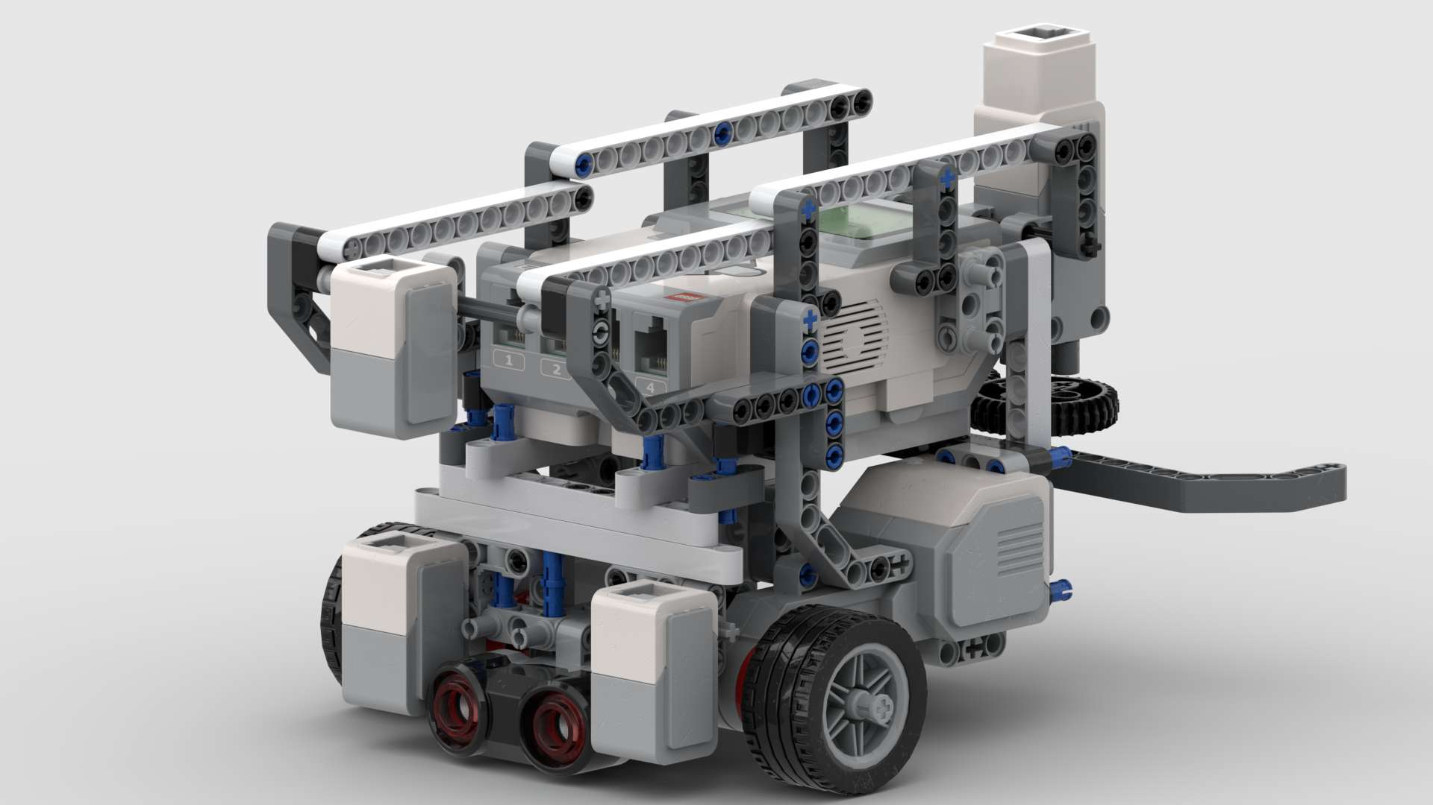
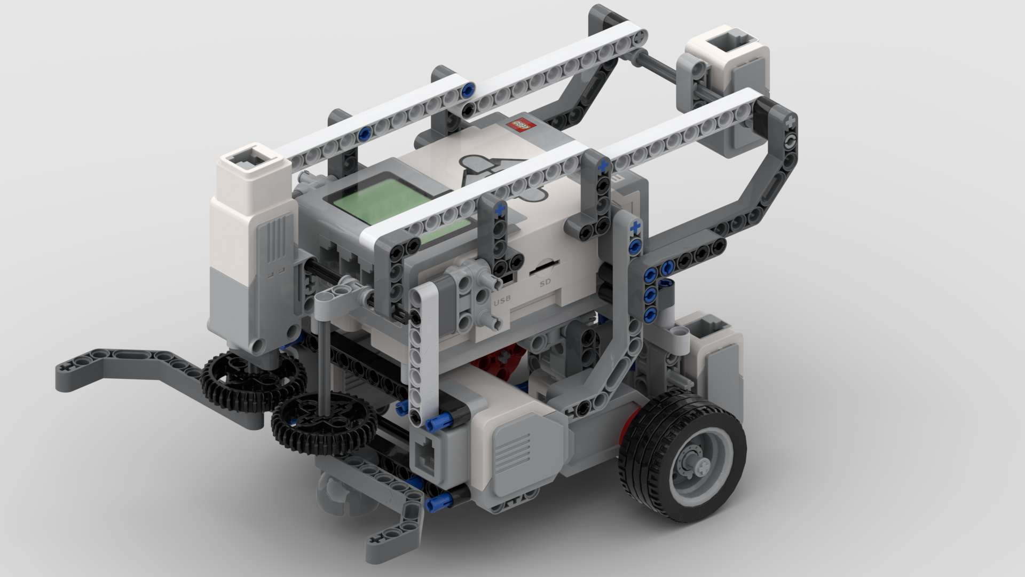
Figure 5: Overall design of the robot

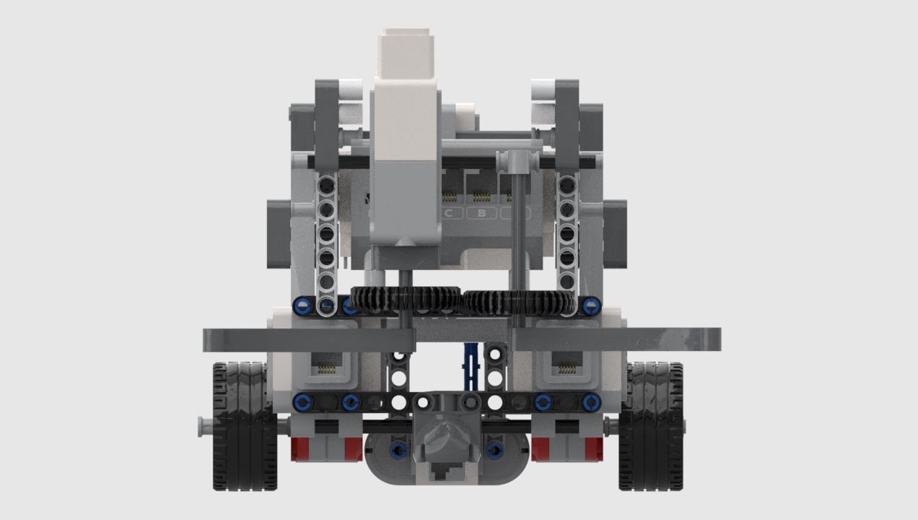
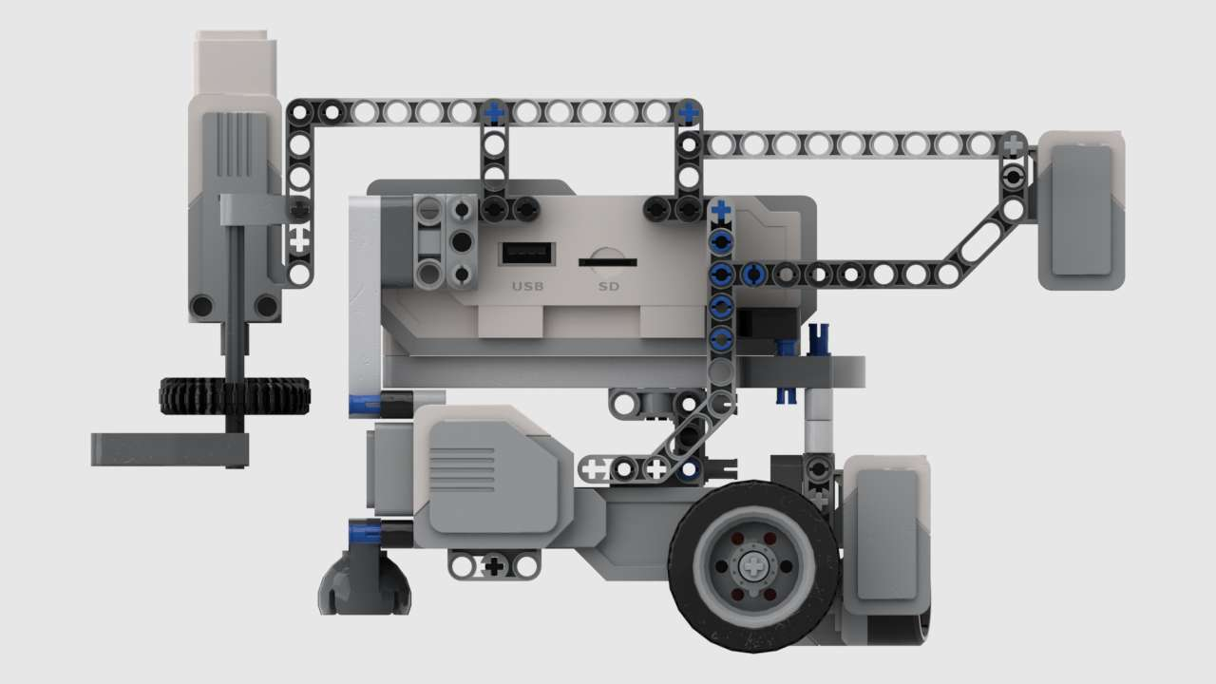
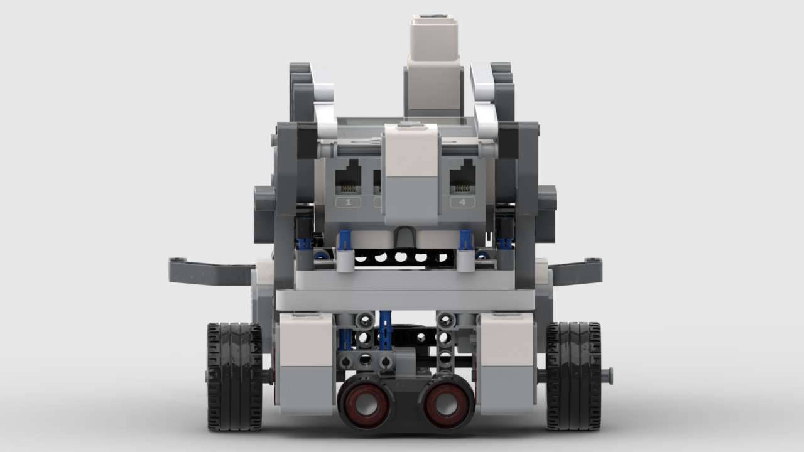
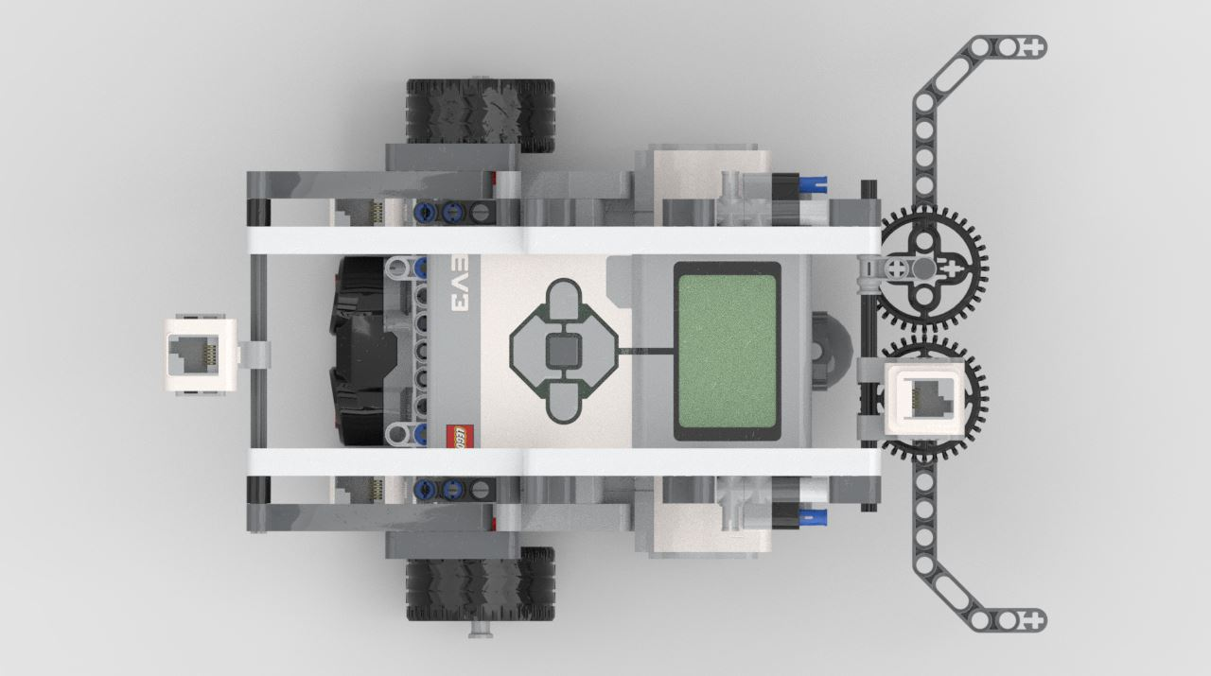
Figure 6: Side views of robot
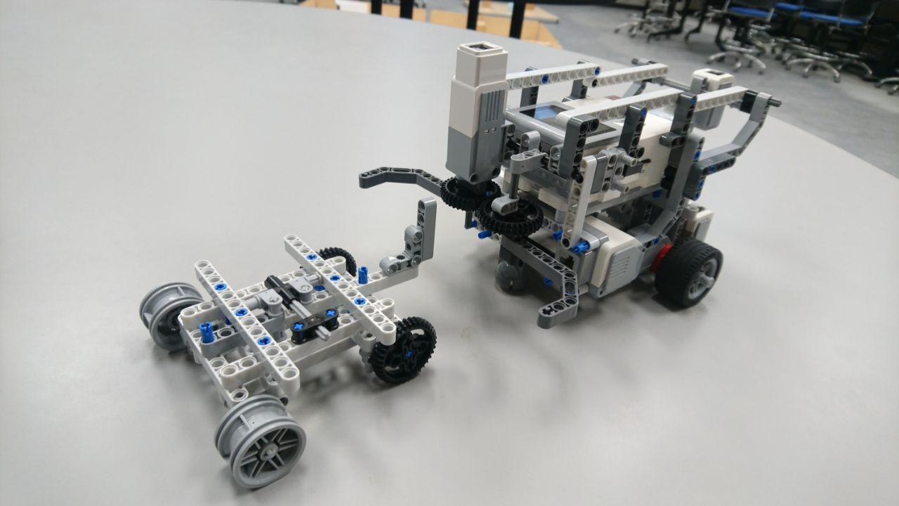
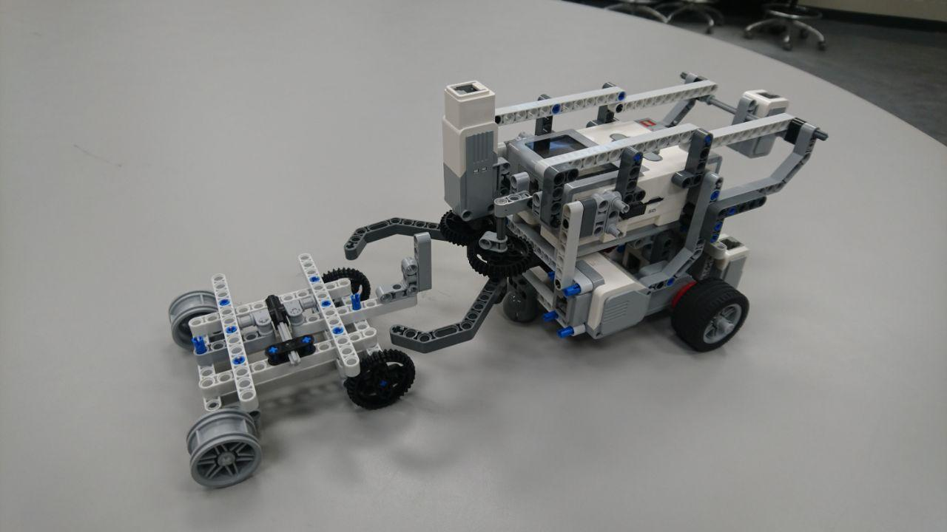
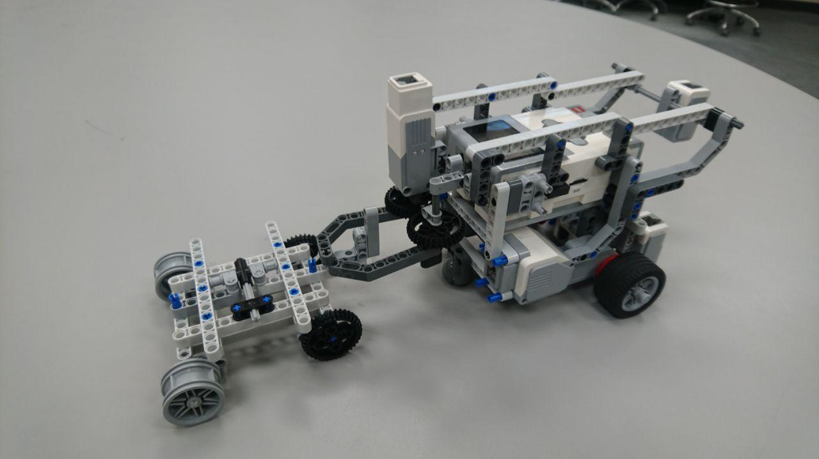
Figure 7: Connecting to trailer
1
2
3

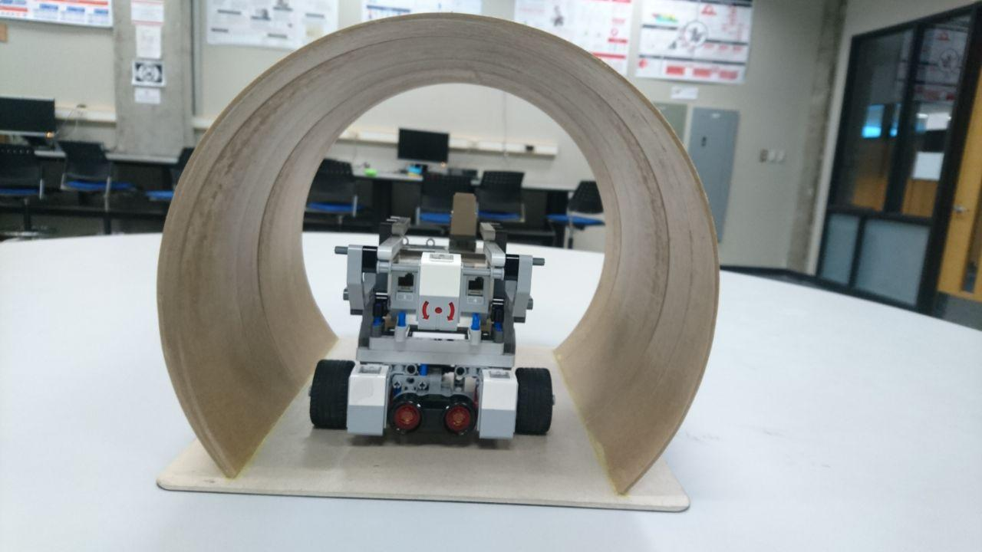
Figure 8: Robot dimensions in tunnel
155 mm
213 mm

149 mm
250 mm

9.4 – EVALUATION TABLE

Advantages | Disadvantages
Dimensions of the robot within constraints (tunnel size) | Battery not easily accessible
The robot is narrow | The claw and grabbing mechanism may be less consistent
The robot is mostly stable | The pickup claw is not very stable
Two colour sensors for drift  correction | A medium motor is heavy - adds weight on the rear, reducing stability

9.5 – FUTURE IMPROVEMENTS
The most notable weakness of our current design is the pickup claw. This part of the robot is less stable than the other components. This reduces the consistency of the robot, as can be seen in Bricklink Studio’s stability test (Figure 9). This weakness appears to be due to the axle between the motor and the gears, which does not move freely enough to transmit motion effectively. Another issue to be addressed is the added weight caused by the medium motor responsible for the pickup mechanism. The effects of this weight imbalance can be reduced by moving the motor closer to the center of the robot or adding counterweighting to its front. Finally, it would be useful to swap the battery to charge or change for another one. However, this would require modifications in the base of the robot and would likely increase its width, reducing maneuverability on the course.
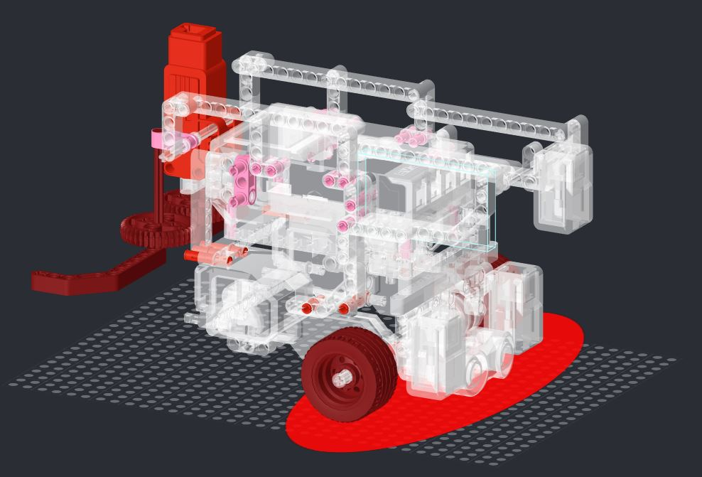
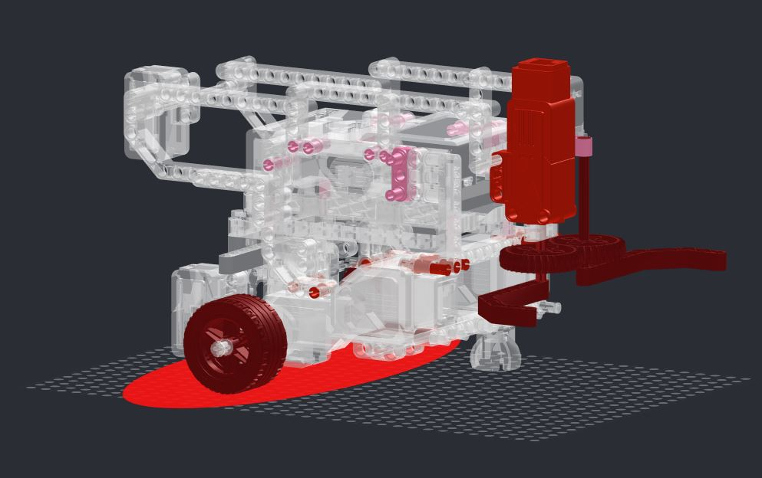
Figure 9: Stability analysis (darker shades of red show less stable components)

9.7 – TIMELINE OF DESIGN MODIFICATION
(Any future hardware modifications will be recorded in this section)

9.7.1 – ROBOT V1.1
We made a minor change in the placement of the colour/light sensor placed on the top of the robot and added obstacle detection and avoidance for objects facing the robot.
- The angle of the color/light sensor has been modified from 90° (facing the ground) to 45°.
- The modification of the top mounted colour/light sensor angle allows the sensor to detect objects facing the robot in addition to detecting the stranded vehicle.
- Differentiating between the stranded vehicle and the obstacles would be done by detecting the colour of the objects (the colour white would correspond to an object and another color would correspond to the stranded vehicle)

9.7.1.1 – EVALUATION TABLE

Advantages | Disadvantages
Provides obstacle detection without another sensor on the robot | Less accurate than object detection with ultrasonic sensor
Reduces the number of sensor threads by reducing number of sensors connected to robot | The light sensor has a smaller range than the ultrasonic sensor, thus delaying starting obstacle avoidance action later
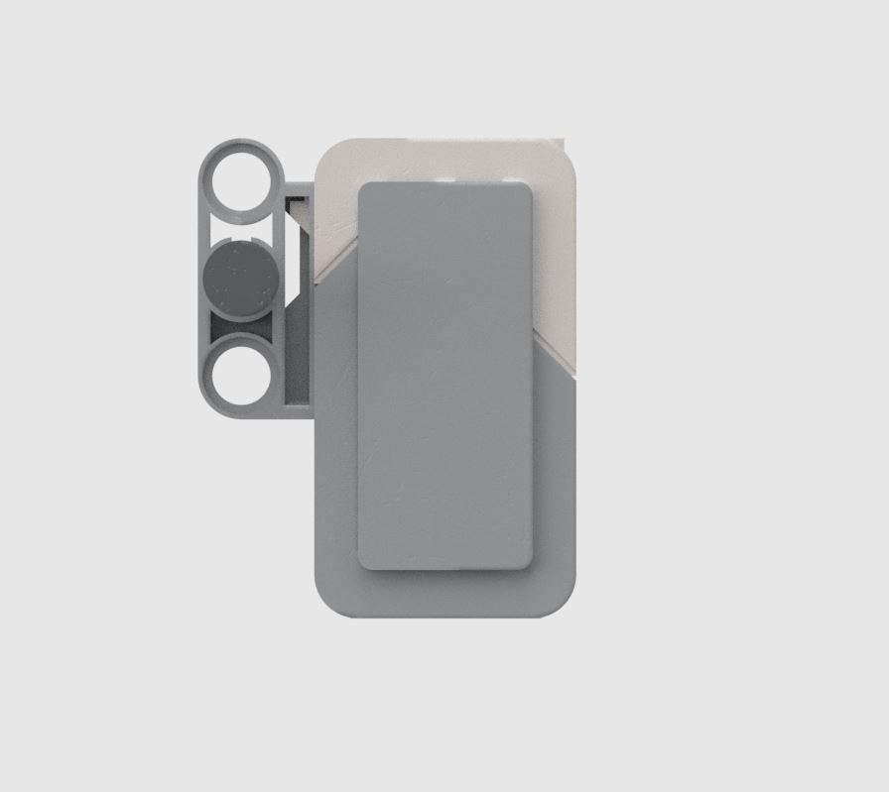
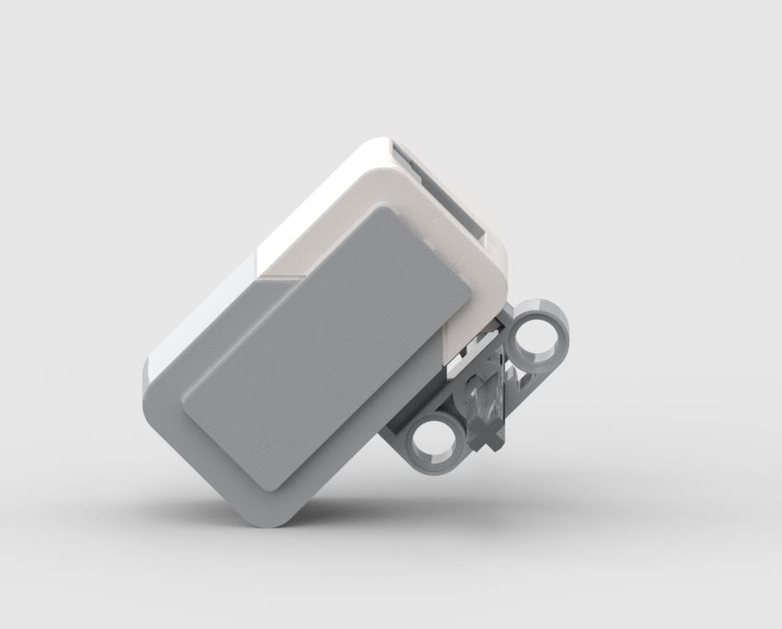
Figure 10: Mounting of top light sensor

90°
45°
Ground

10.0 – COVID-19 UPDATE
The COVID-19 pandemic resulted in cuts in the budget allocated to all subgroups of the team, including the hardware subgroup. Although the initial design and testing was completed before the scheduling change, we did not have access to the robot after the schedules changed. This meant we were not able to improve or test the robot after the changes.
To help the future engineering team resuming the project, this section will list in detail the remaining steps necessary to finalize the mechanical structure of the robot.

10.1 – Instructions on resuming the hardware design
- Read the following sections from the following documents to understand the requirements, availability, compatibility, limitations and capabilities in terms of hardware:
  - Sections 2.0 and 4.0 - Requirements Document
  - Sections 2.0 and 3.0 – Constraints Document
  - Sections 2.0, 3.0, 5.0, 6.0 and 7.1 – System Document
- Read sections 2.0 to 9.0 from the current document (Hardware and Mechanical Structure). This document is essential to resuming the hardware design, as it details the hardware design process and decisions taken by the previous engineering team.
- View the hardware model and build the robot:
  - Open the design files (located in the “Design Files” Folder) in Lego Digital Designer or Bricklink Studio to view the model (Instructions on opening design files can be found in the “Instructions Folder”)
  - Build the physical model following either the “Building Instructions PDF” or the Building guide mode in Lego Digital Designer (Instructions on generating the building guide in LDD can be found in the “Instructions Folder”).
- Refer to Section 9.6 (of this document), which details possible areas of improvements.
- Make minor adjustments/improvements to the design based on the feedback received from the testing and software leads.

11.0 – TESTS
Refer to the Testing Document for a detailed description of the testing procedure and its results.

12.0 – GLOSSARY OF TERMS
- EV3: The latest version of the Lego robotics kit (including the processor brick), the base on which we are building our robot.
- LEGO Digital Designer (LDD): LDD is a freeware computer program produced by the Lego Group that allows users to build models using virtual Lego bricks, in a computer-aided design like manner.
- LDD File: A Lego Digital Designer file, the software used for modeling of Lego creations on the computer
- LXF/LDR: standard file extension for Lego CAD programs that allow the user to create virtual models and scenes. It can also be used to document models and physical builds. (refer to the “Instructions on opening hardware models in Lego Digital Designer” document).
- Bricklink Studio: Bricklink Studio is an unofficial Lego designer program with additional features not available in Lego Digital Designer, including high-quality 3D rendering, model animation, and model stability analysis.

